
Project Report On

Smart Car Dashboard



Submitted in Partial Fulfillment for the award of
Post Graduate Diploma in Embedded Systems and Design
(PG-DESD)
from
C-DAC, ACTS (Pune)
Guided by:
Mr. Shreepad Deshpande

Presented by:
Mr. Akash Dubey | PRN:250840130005
Mr. Allu Taraka Rama Sai Aravind | PRN:250840130008
Mr. Bhavesh Chandrashekhar Satkar | PRN:250840130010
Mr. Nadarge Shivam Santosh | PRN:250840130027
Mr. Sambaladeevi Gowtham | PRN:250840130042

Centre for Development of Advanced Computing (C-DAC), Pune

This project “Smart Car Dashboard” was a great learning experience for us and we are submitting this work to Advanced Computing Training School (CDAC ACTS).
We are very glad to mention the name of Mr.Shreepad Deshpande for their valuable guidance to work on this project. Their guidance and support helped me to overcome various obstacles and intricacies during the course of project work.
Our heartfelt thanks goes to Ms. Jubera Khan (Course Coordinator, PG-DESD) who gave all the required support and kind coordination to provide all the necessities like required hardware, internet facility, and extra Lab hours to complete the project and throughout the course up to the last day here in C-DAC ACTS, Pune.

S. No. | Title | Page No.
 | Front Page | 1
 | Acknowledgement | 2
 | Table of Contents | 3
 | Abstract | 4
1 | Introduction | 5
2 | Literature Survey | 6
2.1 | Introduction | 6
2.2 | Research Paper Description | 6
3 | Methodology and Techniques | 8
3.1 | Methodology | 8
3.2 | Hardware Description | 10
3.3 | Software Modules Description | 17
3.4 | Flow Chart | 18
4 | Implementation | 19
4.1 | System Overview | 19
4.2 | Component Lists and Purpose | 19
4.3 | STM32F407VGT6 Pin Configuration | 20
4.4 | STM32F407VGT6 Clock Configuration | 21
4.5 | Communication Flow | 21
4.6 | STM32 Task Architecture | 22
4.7 | CAN Frame Protocol | 22
4.8 | Sensor Data Acquisition | 23
4.9 | Communication Protocol | 23
4.10 | RTOS | 32
5 | Results | 34
6 | Conclusion | 37
6.2 | Future Scope | 37
7 | References | 39

Abstract

The rapid advancement of automotive electronics has led to the integration of real-time embedded systems, vehicle communication networks, cloud connectivity, and advanced human–machine interfaces. This project presents the design and implementation of a Smart Car Dashboard System based on an embedded real-time architecture using an STM32F407VGT6 microcontroller development board running FreeRTOS. The system monitors critical vehicle parameters such as vehicle speed, battery status, seatbelt condition, and door ajar status and transmits this data over a Controller Area Network (CAN) bus.
The STM32 microcontroller functions as a vehicle Electronic Control Unit (ECU), where multiple FreeRTOS tasks are employed to ensure deterministic data acquisition, processing, and CAN communication. An ESP32 module is used as a gateway ECU that receives CAN data from the STM32, processes the information, and forwards it to two destinations: a DWIN LCD display for real-time visualization and Amazon Web Services (AWS) IoT for cloud-based data storage and monitoring. Communication between the ESP32 and AWS is achieved using the MQTT protocol, enabling reliable and scalable cloud integration.
The DWIN LCD provides an interactive and intuitive graphical interface to display vehicle parameters in real time, enhancing user awareness and safety. The proposed system demonstrates a modular and scalable automotive dashboard architecture that closely resembles real-world vehicle telematics and instrumentation systems. This project highlights the effective integration of real-time operating systems, automotive communication protocols, IoT cloud services, and embedded graphical displays, making it suitable for modern intelligent vehicle applications.

Keywords: Smart Car Dashboard, STM32F407, FreeRTOS, CAN Bus, ESP32, AWS IoT,
DWIN LCD, Real-Time Embedded Syste

Chapter 1

INTRODUCTION

Modern automobiles are increasingly dependent on embedded electronic systems to enhance vehicle safety, performance, and user experience. Traditional mechanical dashboards have evolved into intelligent digital dashboards capable of monitoring, processing, and displaying real-time vehicle information. With the growing demand for connected vehicles, there is a strong need for systems that combine real-time data acquisition, reliable in-vehicle communication, cloud connectivity, and intuitive human–machine interfaces (HMI).
In automotive systems, multiple Electronic Control Units (ECUs) are responsible for monitoring and controlling various vehicle functions such as speed measurement, battery management, and safety features. These ECUs must communicate with each other in a deterministic and fault-tolerant manner. The Controller Area Network (CAN) protocol has become the industry standard for in-vehicle communication due to its robustness, real-time capability, and noise immunity. To manage multiple concurrent operations efficiently, Real-Time Operating Systems (RTOS) such as FreeRTOS are widely used in automotive embedded applications.
This project focuses on the design and implementation of a Smart Car Dashboard System using an STM32F407VGT6 microcontroller operating with FreeRTOS as the primary vehicle ECU. The STM32 continuously monitors key vehicle parameters including vehicle speed, battery status, seatbelt status, and door ajar condition. These parameters are transmitted over a CAN bus to an ESP32-based gateway ECU, which acts as an interface between the vehicle network, the cloud, and the display system.
The ESP32 enables wireless connectivity and forwards the received CAN data to Amazon Web Services (AWS) IoT using the MQTT protocol, allowing remote monitoring and data logging. In parallel, the ESP32 communicates with a DWIN LCD display using a serial interface to provide real-time visualization of vehicle parameters to the user. This separation of responsibilities ensures that time-critical vehicle operations remain isolated from cloud and display processing, improving system reliability and scalability.
The proposed system emulates a real-world automotive dashboard and telematics architecture, demonstrating the practical integration of real-time embedded systems, automotive communication protocols, IoT cloud platforms, and graphical display technologies. The project serves as a foundation for future enhancements such as fault diagnostics, data analytics, over-the-air updates, and advanced driver assistance features.

Chapter 2

LITERATURE SURVEY

Introduction

A literature survey is a systematic and comprehensive review of previously published research work related to the proposed project. It involves collecting information from journals, research papers, technical articles, and conference publications in the domain of interest. The primary objective of conducting a literature survey is to understand existing technologies, methodologies, and system architectures relevant to the research problem. This process helps in identifying the strengths, limitations, and research gaps in existing systems.

The literature survey also assists in selecting appropriate hardware, software, and communication protocols for system design. By analyzing previous research work, the proposed system can be designed more efficiently, avoiding known limitations and incorporating proven techniques. Therefore, conducting a literature survey is an essential step in gathering secondary data and defining the architecture and methodology of the project.

Research Papers for Smart Car Dashboard

[A] PAPER 1:

In [1], the authors presented a CAN-based vehicle monitoring system for transmitting real-time vehicle parameters such as speed, fuel level, and engine status between multiple Electronic Control Units (ECUs). The system utilized the Controller Area Network protocol to ensure reliable and deterministic communication in an automotive environment. The results demonstrated improved communication reliability, reduced wiring complexity, and enhanced system robustness compared to conventional serial communication methods. However, the system lacked cloud connectivity and advanced visualization features.

[B] PAPER 2:

In [2], this research described the implementation of an RTOS-based automotive ECU using a real-time operating system to manage multiple vehicle tasks concurrently. The study focused on task scheduling, prioritization, and inter-task communication for automotive applications. The results showed that RTOS-based systems provide better responsiveness, scalability, and fault handling compared to traditional super-loop architectures. However, the proposed system did not include external data transmission or

cloud-based monitoring.

[C] PAPER 3:

In [3], the project presented an IoT-enabled vehicle data monitoring system where vehicle parameters were transmitted to a cloud platform for remote access and analysis. The system used a Wi-Fi-enabled microcontroller as a gateway to upload data using lightweight communication protocols. Experimental results showed effective real-time monitoring and data logging. The study highlighted the benefits of cloud connectivity but did not address real-time constraints or in-vehicle communication standards such as CAN.

[D] PAPER 4:

In [4], this paper focused on the design of a digital automotive dashboard system using an intelligent LCD display. The dashboard displayed vehicle parameters such as speed, battery level, and warning indicators using a serial communication interface. The use of an intelligent display module reduced the processing load on the main controller and improved user interaction. However, the system was limited to local visualization and lacked integration with cloud services and vehicle networks.

[E] PAPER 5:

In [5], the authors discussed a gateway-based vehicle architecture where data from multiple ECUs was aggregated and forwarded to external systems. The study emphasized separating real-time vehicle control from non-critical tasks such as data logging and cloud communication. Results showed improved system reliability and scalability. However, the implementation complexity increased due to the involvement of multiple controllers.

[F] PAPER 6:

In [6], this research focused on a smart vehicle telemetry system that integrated CAN communication, real-time processing, and cloud connectivity. The system transmitted vehicle parameters such as speed and battery status to a remote server for monitoring and analysis. The results indicated improved vehicle data accessibility and system performance. However, the system lacked an advanced graphical display for real-time user interaction within the vehicle.

Chapter 3

METHOLOGY AND TECHNIQUES

3.1 Methodology:

The proposed Smart Car Dashboard System is designed using a modular and layered approach, where sensing, processing, communication, visualization, and cloud connectivity are handled in an organized manner. The overall methodology is explained with reference to the block diagram shown above.

1. Sensor Data Acquisition

The system begins with the acquisition of real-time vehicle parameters using multiple sensors connected to the STM32F407VGT6 microcontroller. The ACS712 current sensor is connected in series with the battery to measure the charging and discharging current, while the voltage sensor module is connected across the battery terminals to measure battery voltage. Both sensors provide analog outputs, which are interfaced with the ADC pins of the STM32.

The LM393 speed sensor generates digital pulses proportional to the rotational speed of the wheel or motor, which are captured by the STM32 using GPIO or timer inputs. The LM35 temperature sensor measures the temperature of the battery and motor and provides an analog voltage output proportional to temperature. Additionally, safety-related inputs such as driver door switch, passenger door switch, and seatbelt switch are connected to GPIO pins of the STM32 for continuous monitoring.

2. Data Processing Using STM32 with FreeRTOS

The STM32F407VGT6 acts as the primary vehicle ECU and runs FreeRTOS to manage multiple tasks concurrently. Separate tasks are created for speed calculation, battery monitoring, temperature sensing, safety status detection, and CAN communication. The ADC values from current, voltage, and temperature sensors are processed and converted into meaningful physical quantities. Battery voltage and current data are combined to estimate the battery percentage (State of Charge).

By using FreeRTOS, the system ensures deterministic execution, priority-based task scheduling, and reliable real-time performance, which is essential for automotive applications.

3. CAN Communication Between STM32 and ESP32

After processing, the STM32 formats the vehicle data into CAN frames. The built-in CAN controller of the STM32 transmits these frames through the SN65HVD230 CAN transceiver, which converts logic-level CAN signals into differential CANH and CANL signals. These signals are transmitted over the CAN bus to the MCP2515 CAN module connected to the ESP32.

The MCP2515 communicates with the ESP32 using the SPI protocol and handles CAN message reception, filtering, and error detection. This CAN-based communication ensures reliable, noise-immune, and real-time data transfer between the vehicle ECU and the gateway controller.

4. Gateway Processing Using ESP32

The ESP32 functions as a gateway controller in the system. It receives vehicle data from the MCP2515 CAN module and processes it for further use. The ESP32 separates real-time vehicle communication from non-critical tasks such as display handling and cloud connectivity, thereby reducing the load on the STM32 and improving system reliability.

5. Display Interface Using DWIN LCD

For real-time visualization, the ESP32 communicates with the DWIN LCD display through UART using an FPC connector. The display screens are pre-designed using DWIN tools, and vehicle parameters such as speed, battery percentage, temperature, and warning indicators are updated by sending serial commands from the ESP32. This approach allows efficient graphical display without heavy processing overhead on the microcontroller.

6. Cloud Connectivity

Simultaneously, the ESP32 sends the received vehicle data to the AWS IoT cloud using Wi-Fi and the MQTT protocol. This enables remote monitoring, data logging, and future analysis of vehicle parameters. Cloud connectivity enhances the system by allowing real-time access to vehicle data from anywhere.

7. Overall System Operation

The entire system operates in a continuous loop where sensor data is acquired, processed, transmitted over CAN, displayed on the dashboard, and uploaded to the cloud. The modular architecture ensures scalability, fault isolation, and ease of future enhancements such as diagnostics, alerts, and advanced analytics.

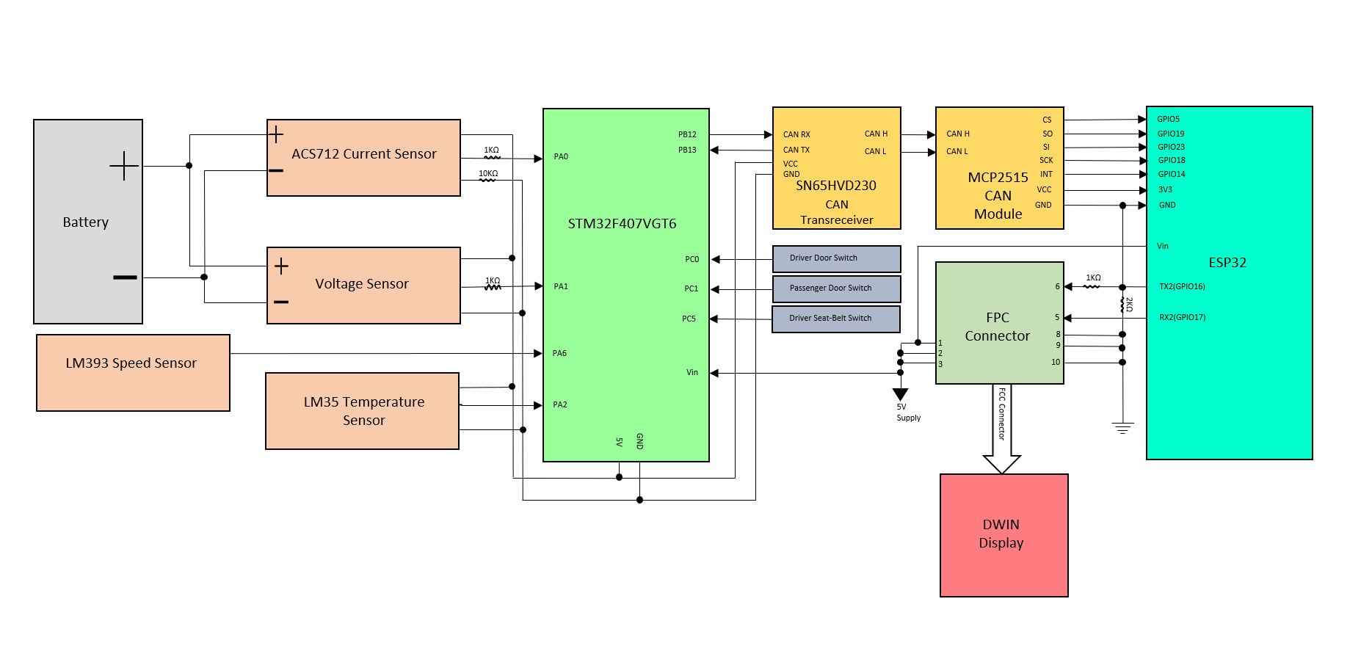

Fig 1 : Circuit-Block Diagram

3.2 Hardware Description

STM32F40VGT6 Discovery Board:
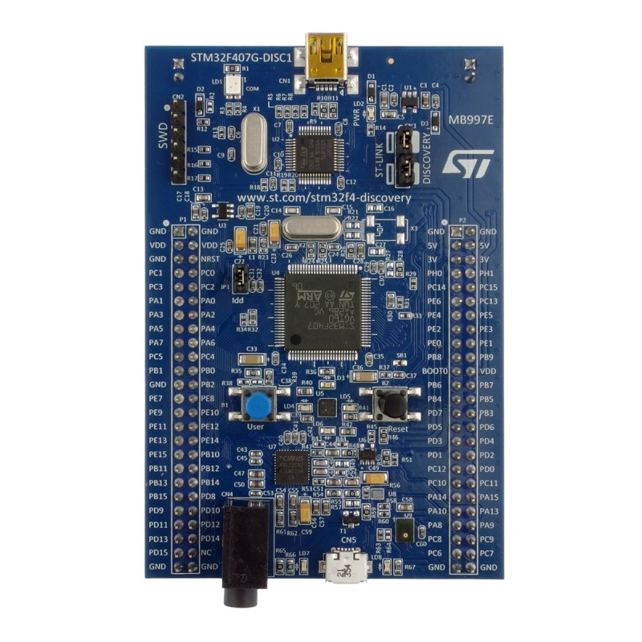
Fig 2 : STM32F407VGT6

The STM32F407VGT6 is a 32-bit ARM Cortex-M4 based microcontroller with a maximum operating frequency of 168 MHz. In the proposed smart car dashboard system, it functions as the main vehicle ECU, responsible for collecting and processing real-time data such as vehicle speed, battery status, seatbelt indication, and door ajar status. The microcontroller runs FreeRTOS to handle multiple tasks concurrently with deterministic timing and uses its integrated CAN controller to transmit processed vehicle data to the ESP32 gateway. Its high processing speed, real-time capability, and extensive peripheral support make it well suited for automotive and real-time embedded applications.

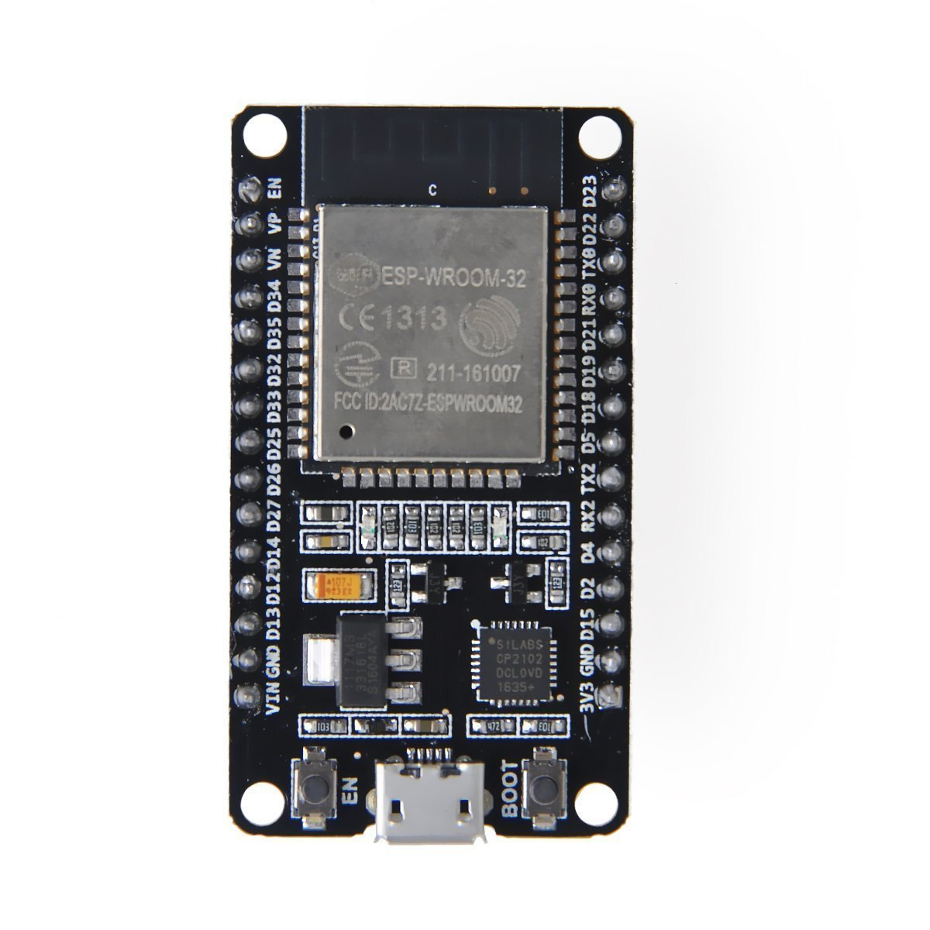
ESP32 Dev Module:

Fig 3 : ESP32 Dev Module

The ESP32 is a powerful, low-cost microcontroller with built-in Wi-Fi and Bluetooth

capabilities, widely used in IoT applications. In this smart car dashboard project, the

ESP32 functions as a gateway ECU between the in-vehicle network and external systems. It receives real-time vehicle data such as speed, battery status, seatbelt status, and door ajar information from the STM32 controller via the CAN bus. The ESP32 processes and formats this data for further communication. Using its integrated Wi-Fi module, the ESP32 transmits the received vehicle parameters to the AWS IoT cloud using the MQTT protocol, enabling remote monitoring and data logging. Simultaneously, it communicates with the DWIN LCD display through a serial interface to provide real-time visualization of vehicle information to the driver. By offloading cloud connectivity and display handling from the STM32, the ESP32 helps maintain real-time performance and improves overall system reliability and scalability

SN65HVD230 CAN Trans-receiver:
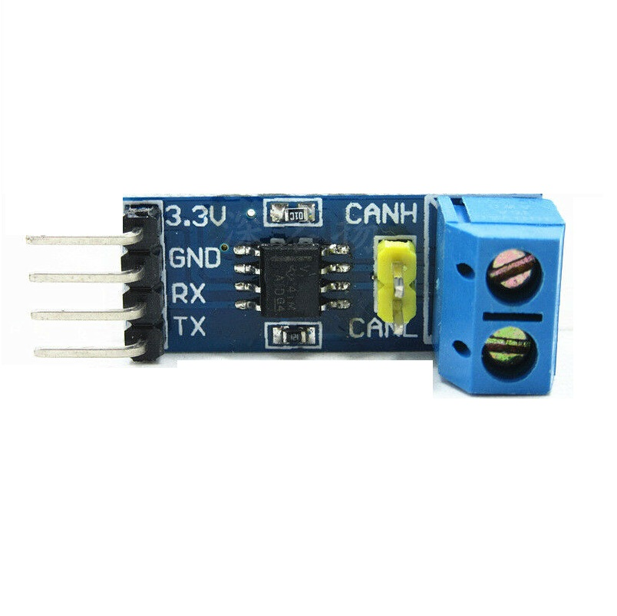
Fig 4: SN65HVD230 CAN Trans-receiver

The SN65HVD230 is a high-speed CAN transceiver designed for reliable communication in automotive and industrial environments. In this smart car dashboard project, it acts as the physical interface between the CAN controller of the STM32/ESP32 and the CAN bus lines (CANH and CANL). The transceiver converts the logic-level CAN signals from the microcontroller into differential signals suitable for transmission over the CAN bus and vice versa. SN65HVD230 provides high noise immunity, low electromagnetic interference, and robust fault protection, which are essential for in-vehicle communication. It supports standard CAN data rates and ensures stable communication between the STM32 ECU and the ESP32 gateway. By using this transceiver, the system achieves reliable and error-resistant data exchange for real-time vehicle parameters such as speed, battery status, and safety indicators.
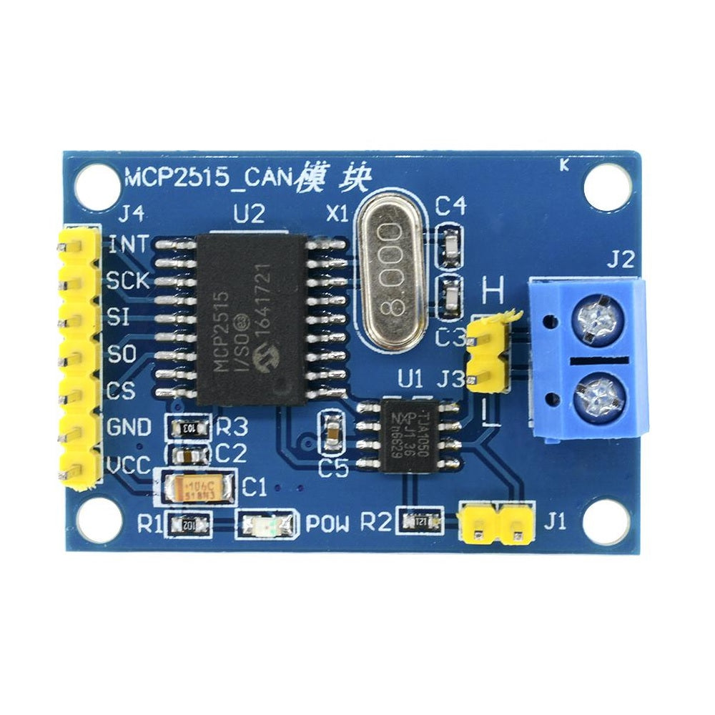
- MCP2515 CAN Module:
Fig 5 : MCP2515 CAN Module

The MCP2515 CAN module is a standalone CAN controller that communicates with microcontrollers using the SPI interface. In this smart car dashboard project, it is used to provide CAN communication capability to the ESP32, which does not have a built-in CAN controller. The module handles CAN protocol functions such as message framing, filtering, arbitration, and error handling. The MCP2515 works in conjunction with a CAN transceiver to transmit and receive vehicle data over the CAN bus. It enables reliable communication between the STM32 ECU and the ESP32 gateway, allowing real-time transfer of parameters such as speed, battery status, seatbelt indication, and door ajar status. Its flexibility and compatibility make it suitable for implementing CAN-based automotive networks in embedded systems.

DWIN DMG80480C070 LCD Display:
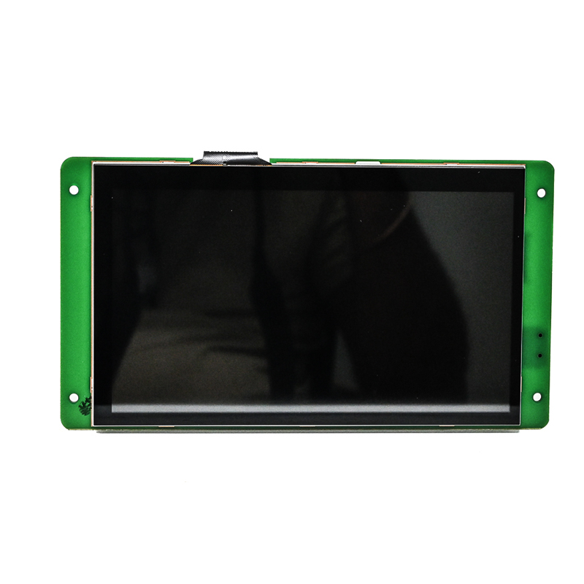
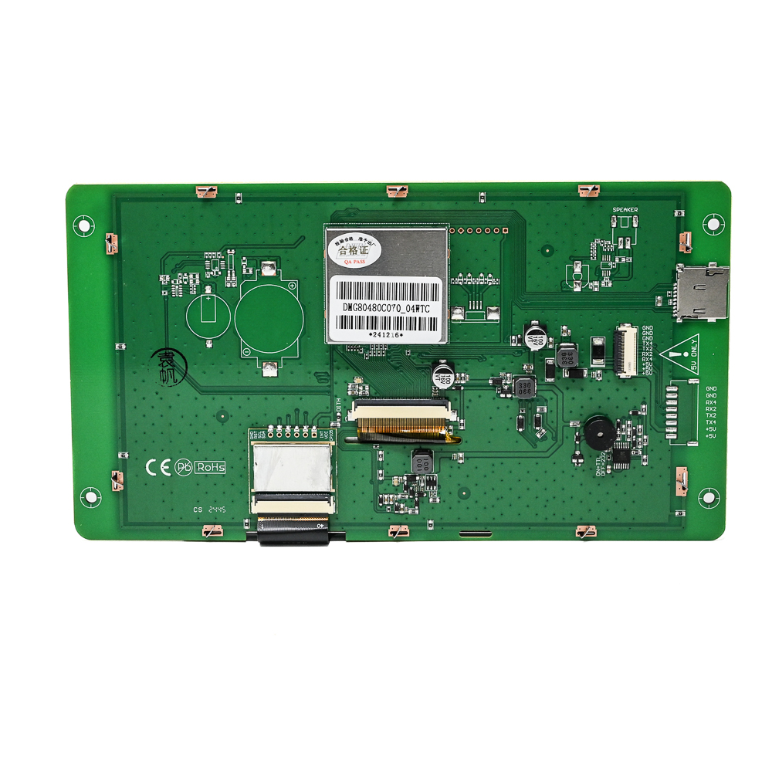
Fig 6 : DWIN Display (Front View)

Fig 7 : DWIN Display (Rear View)

The DWIN DMG80480C070 is a 7-inch intelligent TFT LCD display with a resolution of 800×480 pixels, designed for embedded human–machine interface applications. In this smart car dashboard project, it serves as the visual display unit, presenting real-time vehicle information such as speed, battery status, seatbelt warning, and door ajar indication. The display communicates with the ESP32 through a serial interface using the DGUS protocol. The intelligent nature of the DWIN display allows most of the graphical processing to be handled internally, reducing the computational load on the microcontroller. Custom dashboard screens, icons, and indicators are designed using DWIN’s development tools and mapped to variables updated by the ESP32. This enables smooth, real-time visualization and improves user interaction and overall dashboard performance.

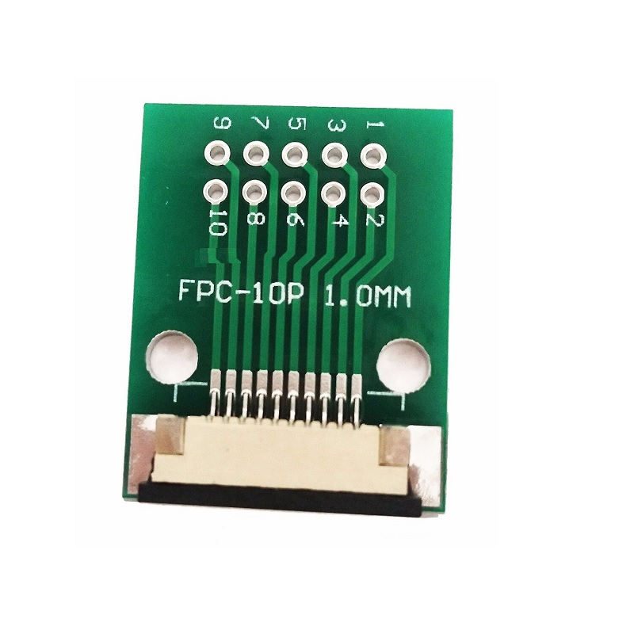
FPC-10P 1 mm Connector:
Fig 8 : FPC-10P 1mm Connector

The FPC-10P 1 mm connector is a flat flexible cable interface used to establish electrical connections between the DWIN DMG80480C070 LCD display and the ESP32-based control circuitry. In this smart car dashboard project, the FPC connector carries essential signals such as power supply, ground, and serial communication lines (TX, RX) required for data exchange between the display and the ESP32. It ensures a stable and low-profile connection, which is important for maintaining reliable communication in an embedded automotive environment. The 1 mm pitch design allows compact integration of the display with the ESP32 module, reducing wiring complexity and improving mechanical robustness. By using the FPC connector, the system achieves secure and organized signal routing, enabling the ESP32 to continuously update real-time vehicle parameters such as speed, battery status, and warning indicators on the DWIN LCD display.

ACS712 Current Sensor Module:
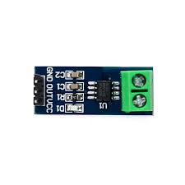
Fig 9 : ACS712 Current Sensor Module

The ACS712 is a Hall-effect–based current sensor used for measuring both AC and DC currents. In this smart car dashboard project, it is employed to measure the battery current, which is an essential parameter for estimating the battery status. The sensor is connected in series with the battery load, and it provides an analog output voltage proportional to the current flowing through the system. The analog output of the ACS712 is interfaced with the ADC pin of the STM32 microcontroller, where the current value is sampled and processed in real time. This measured current, along with battery voltage data, is used to calculate the battery percentage. The processed battery information is then transmitted over the CAN bus to the ESP32 gateway for display on the DWIN LCD and for cloud monitoring through AWS.

Voltage Sensor Module:
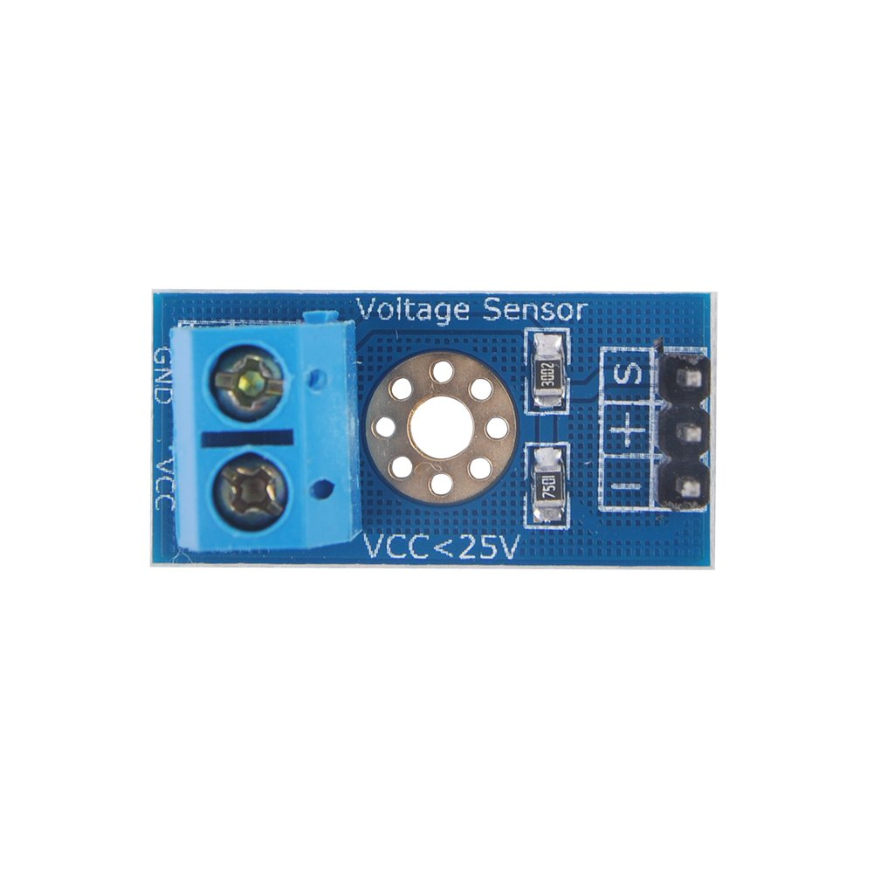

Fig 10 : Voltage Sensor Module

The Voltage Sensor Module is used to measure the battery voltage in the smart car dashboard system. It typically consists of a resistive voltage divider circuit that scales down the high battery voltage to a safe level suitable for the microcontroller’s ADC input. In this project, the module is connected across the vehicle battery terminals to continuously monitor the battery voltage. The scaled analog output of the voltage sensor module is interfaced with an ADC channel of the STM32 microcontroller, where the voltage value is sampled and processed. This voltage data, combined with current measurements from the ACS712 sensor, is used to estimate the battery state of charge. The calculated battery status is then transmitted via the CAN bus to the ESP32 for real-time display on the DWIN LCD and for cloud-based monitoring using AWS.

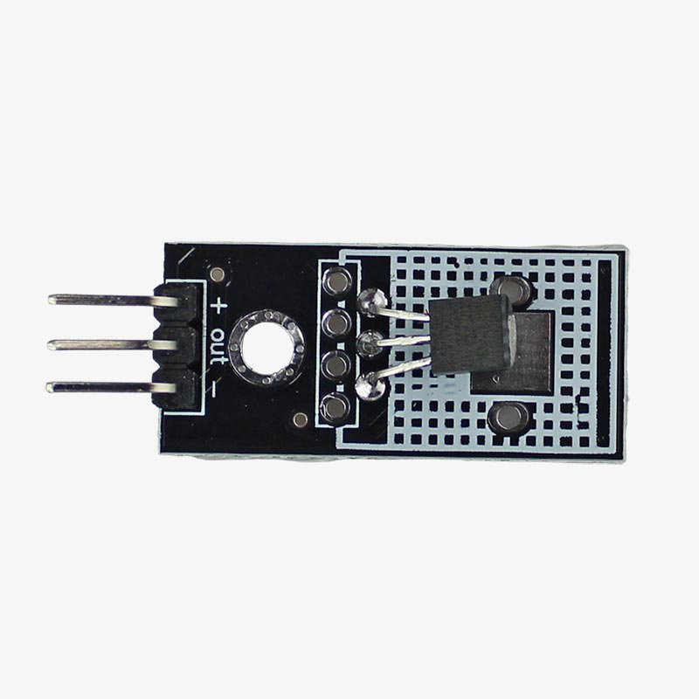
LM35
Fig 11 : LM35 Temperature Sensor Module

The LM35 is a precision analog temperature sensor that provides an output voltage linearly proportional to temperature in degrees Celsius. In this smart car dashboard project, the LM35 is used to monitor the temperature of the vehicle battery and motor, which is critical for ensuring safe operation and preventing overheating conditions. The sensor is placed in close proximity to the battery pack and motor casing to accurately sense temperature variations.The analog output of the LM35 is connected to an ADC input of the STM32 microcontroller, where the temperature data is continuously sampled and processed. The measured temperature values are used for monitoring and safety indication and are transmitted over the CAN bus to the ESP32 gateway. The ESP32 then updates the real-time temperature information on the DWIN LCD display and sends it to the AWS cloud for remote monitoring and analysis.

LM393 Speed Sensor Module:
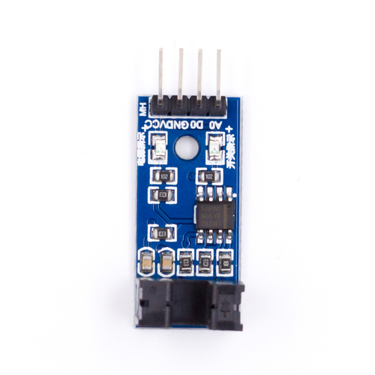
Fig 12 : LM393 Speed Sensor Module

The LM393 Speed Sensor Module is used to measure the rotational speed of the vehicle wheel or motor shaft in the smart car dashboard system. It typically works with an infrared or Hall-effect sensing mechanism and generates digital pulses corresponding to the rotation. In this project, the sensor is positioned near the wheel or motor to detect speed-related signals accurately. The digital output of the LM393 module is connected to a GPIO or timer input of the STM32 microcontroller, where the pulses are counted to calculate the vehicle speed in real time. The processed speed data is then transmitted over the CAN bus to the ESP32 gateway. This speed information is displayed on the DWIN LCD dashboard and sent to the AWS cloud for real-time monitoring and data logging.

3.3 Software Modules Description

STM32CubeIDE:

STM32CubeIDE is an integrated development environment (IDE) developed by STMicroelectronics for STM32 microcontrollers. It combines the STM32CubeMX configuration tool with a powerful Eclipse-based code editor and debugger. STM32CubeIDE allows developers to configure peripherals, generate initialization code, write and compile C/C++ programs, and debug applications using ST-LINK or J-Link probes. It supports real-time variable monitoring, fault analysis, and RTOS-aware debugging, making it a comprehensive platform for embedded development across Windows, Linux, and macOS systems.

Arduino IDE:

Arduino IDE for ESP32 is a beginner-friendly development environment that enables programming of ESP32 microcontrollers using the Arduino framework. By installing the ESP32 board support package via the Board Manager, users can write, compile, and upload sketches using familiar Arduino syntax. The IDE supports a wide range of ESP32 boards and provides access to built-in libraries for Wi-Fi, Bluetooth, sensors, and peripherals. Its simplicity and cross-platform compatibility make it a popular choice for IoT projects, rapid prototyping, and wireless applications involving the ESP32.

3.4 Flowchart
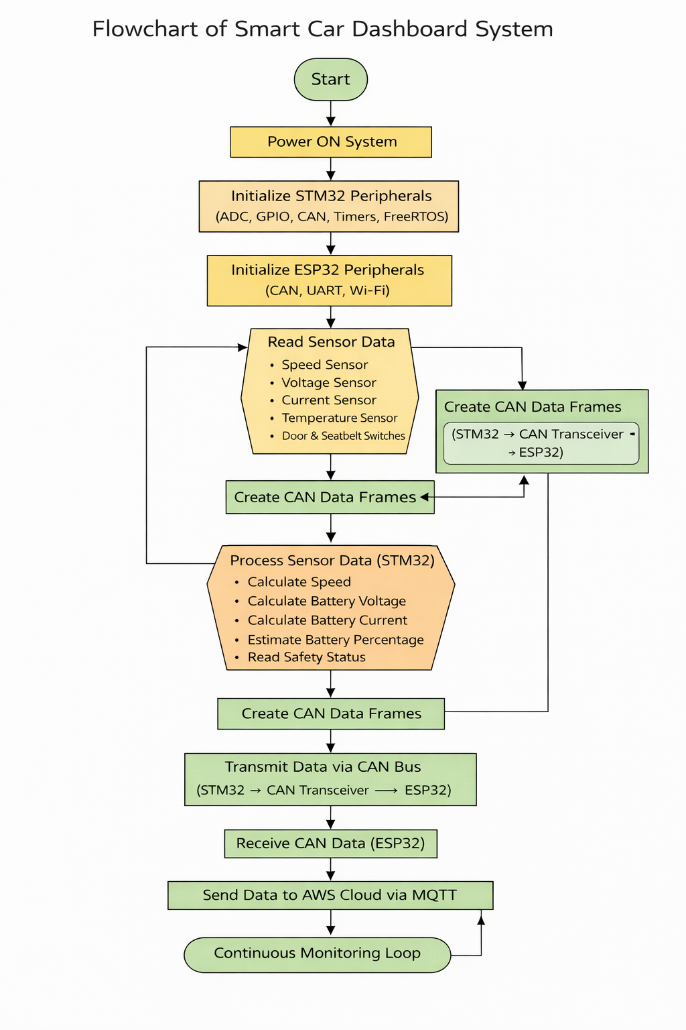
Fig 13 : Flow Chart

Chapter 4

IMPLEMENTATION

4.1 System Overview:

The Smart Car Dashboard System is designed to monitor and display real-time vehicle parameters using an embedded automotive architecture. An STM32F407VGT6 microcontroller acts as the primary ECU, acquiring data from sensors such as speed, battery voltage, current, temperature, and safety switches. The processed data is transmitted to an ESP32 gateway using the CAN communication protocol. The ESP32 forwards the data to a DWIN LCD display for real-time visualization and to the AWS cloud for remote monitoring. The system employs FreeRTOS for reliable real-time task management and ensures robust, scalable, and automotive-grade performance.

4.2 Component List and Purpose:

Component Name | Description | Protocol / Interface Used
STM32F407VGT6 | Main vehicle ECU | ADC, GPIO, CAN
ESP32 | Gateway controller | SPI, UART, Wi-Fi
SN65HVD230 | CAN transceiver | CAN (Physical Layer)
MCP2515 CAN Module | CAN controller | SPI
DWIN DMG80480C070 LCD | Dashboard display | UART (DGUS)
ACS712 | Current measurement | Analog (ADC)
Voltage Sensor Module | Voltage measurement | Analog (ADC)
LM35 | Temperature sensing | Analog (ADC)
LM393 Speed Sensor | Speed detection | Digital GPIO / Timer
Door Switch | Door status input | GPIO
Seatbelt Switch | Seatbelt status input | GPIO
FPC-10P Connector | Display interface | UART, Power
Battery | Power source | DC Supply

4.3 STM32F407VGT6 Pin Configuration:

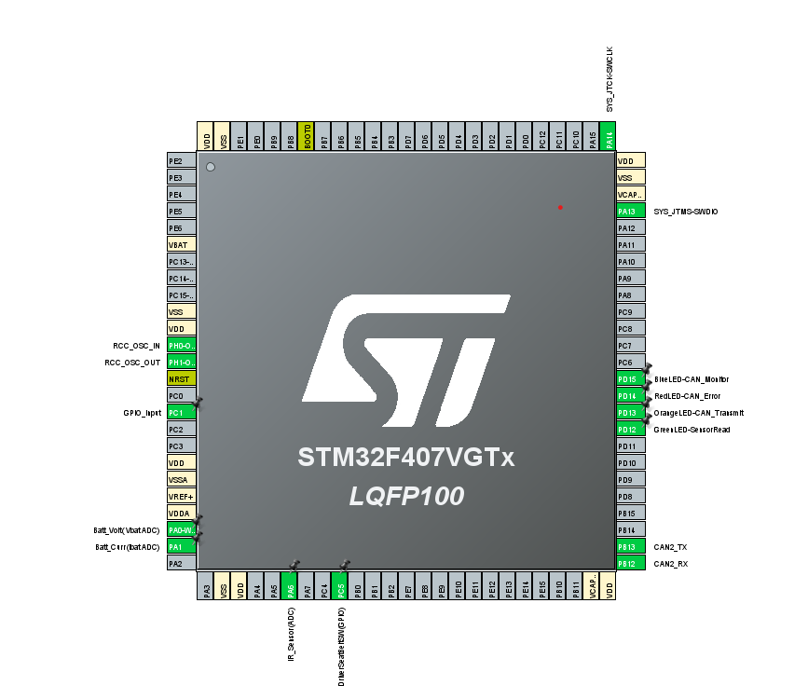
Fig 14 : STM32F407VGT6 Pin Configuration

4.4 STM32F407VGT6 Clock Configuration:

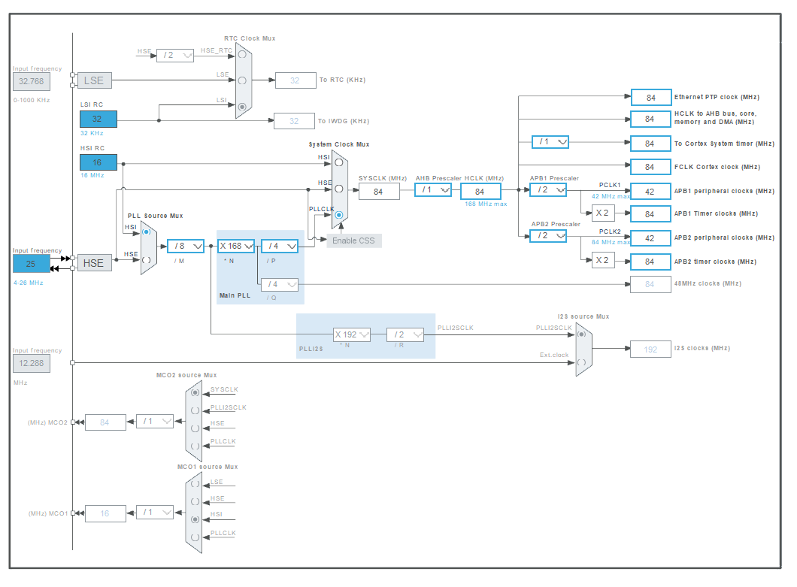
Fig 15 : STM32F407VGT6 Clock Configuration

4.5 Communication Flow:

The STM32F407VGT6 continuously acquires real-time vehicle data such as motor RPM, vehicle speed, battery voltage, current, temperature, and door/seatbelt status using ADCs, timers, and GPIOs under FreeRTOS task scheduling.

The processed sensor data is packed into standard CAN frames with predefined CAN IDs (e.g., motor speed, battery status, vehicle speed, safety status) inside the CAN transmission task.

The STM32 transmits these CAN frames via its CAN2 peripheral, which are converted to differential signals (CANH and CANL) using the SN65HVD230 CAN transceiver.

The CAN data is received on the gateway side through the MCP2515 CAN controller, which communicates with the ESP32 using the SPI interface.

The ESP32 acts as a gateway ECU, decoding the received CAN messages and forwarding real-time vehicle information to the DWIN LCD display via UART communication for dashboard visualization.

Simultaneously, the ESP32 publishes the same vehicle data to the AWS IoT cloud using MQTT over Wi-Fi, enabling remote monitoring, logging, and analysis.

4.6 STM32 Task Architecture:

Task Name | Functionality | Priority | Execution Interval
Task_SensorRead | Reads sensors (RPM, speed, battery, temp, door, seatbelt) | High | 50 ms (20 Hz)
Task_CANTransmit | Prepare & transmit CAN messages | Medium | 100 ms (10 Hz)
Task_Monitor | Monitor CAN bus & system health | Low | 1000 ms (1 Hz)

4.7 CAN Frame Protocol:

CAN ID (Hex) | Message Type | DLC | Data Bytes Description
0x100 | Motor RPM | 2 | Byte0–1: Motor RPM (High, Low)
0x101 | Battery Status | 6 | Byte0–1: Voltage (0.01V),  Byte2: SOC (%),  Byte3–4: Current (0.1A),  Byte5: Temperature (°C)
0x102 | Door & Seatbelt Status | 2 | Byte0: Door Status Bits, Byte1: Seatbelt Status Bits
0x105 | Vehicle Speed | 2 | Byte0–1: Vehicle Speed (km/h)

Sensor Data Acquisition:

The STM32F407VGT6 microcontroller continuously acquires real-time vehicle parameters using its built-in ADC, GPIO, and timer peripherals under FreeRTOS control.

Battery voltage is measured using a voltage sensor module connected across the battery terminals, and its scaled analog output is read through the STM32 ADC.

Battery current is sensed using the ACS712 current sensor, whose analog output is connected to an ADC channel to monitor charging and discharging current.

Battery and motor temperature are monitored using the LM35 temperature sensor, which provides an analog voltage proportional to temperature and is sampled by the ADC.

Vehicle speed and motor RPM are calculated using the LM393 speed sensor, which generates digital pulses captured using timer input capture for accurate speed computation.

Safety-related inputs, such as door status and seatbelt status, are obtained through GPIO pins configured as digital inputs.

All sensor readings are processed periodically inside a high-priority FreeRTOS sensor task, ensuring deterministic and real-time data acquisition.

Communication Protocol:

4.9.1 Controller Area Network (CAN):

The Controller Area Network bus is an International Standardization Organization (ISO) defined serial communications bus originally developed for the automotive industry to replace the complex wiring harness with a two-wire bus. The Controller Area Network bus, or CAN bus, is a vehicle bus standard designed to allow devices and microcontrollers to communicate with each other within a vehicle without a host computer.

CAN is a reliable, real-time protocol that implements a multicast, data-push, publisher/subscriber model. CAN messages are short (data payloads are a maximum of 8 bytes, headers are 11 or 29 bits), so there is no centralized master or hub to be a single point of failure and it is flexible in size. Its real-time features include deterministic message delivery time and global priority with prioritized message IDs.

Bus arbitration is accomplished in CAN using bit dominance, a process where nodes begin to transmit their message headers on the bus, then drop out of the “competition” when a dominant bit is detected on the bus, indicating a message ID of higher priority being transmitted elsewhere. This means bus arbitration does not add overhead because once the bus is “won” the node simply continues sending its message. Because there is no time lost to collisions on a heavily loaded network.

● CAN Network

A CAN network consists of several CAN nodes which are linked via a physical transmission medium (CAN bus). In practice, the CAN network is usually based on a line topology with a linear bus to which a few electronic control units are each connected via CAN interface. The passive star topology may be used as an alternative. An unshielded twisted two-wire line is the physical transmission medium used most frequently in applications(Unshielded Twisted Pair — UTP), over which symmetrical signal transmission occurs. The maximum data rate is 1 Mbit/s. A maximum network extension of about 40 meters is allowed. At the ends of the CAN network, bus termination resistors contribute to preventing transient phenomena (reflections). ISO 11898 specifies the maximum number of CAN nodes as 32.

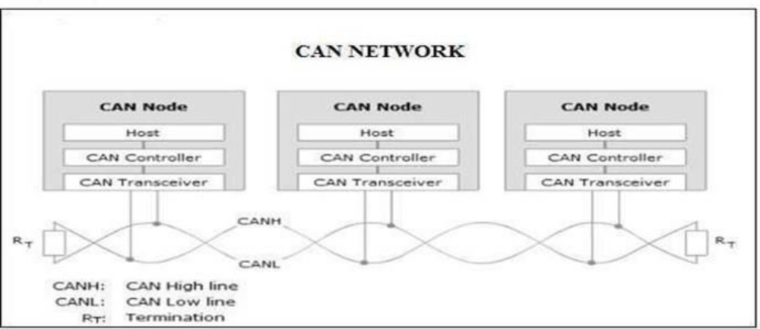
Fig 16 : CAN Network

• CAN BUS

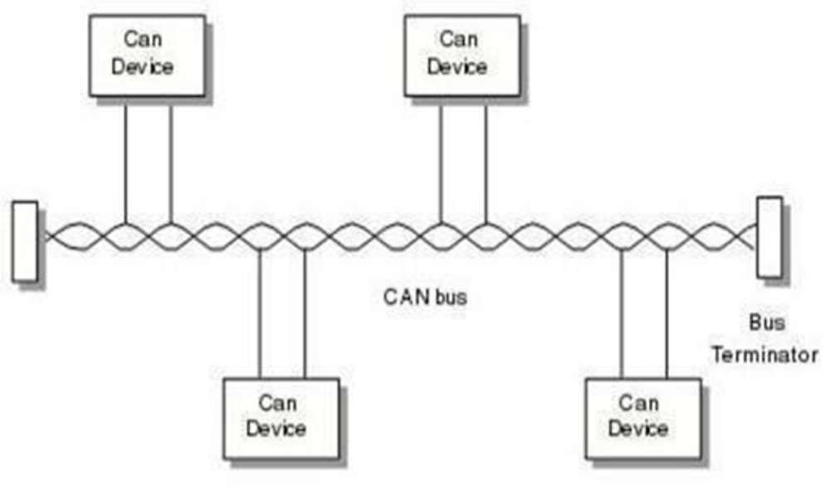
Fig 17 : CAN Bus

Physical signal transmission in a CAN network is based on transmission of differential voltages (differential signal transmission). This effectively eliminates the negative effects of interference voltages induced by motors, ignition systems and switch contacts. Consequently, the transmission medium (CAN bus) consists of two lines: CAN High and CAN Low.

Twisting of the two lines reduces the magnetic field considerably. Therefore, in practice twisted pair conductors are generally used as the physical transmission medium. Due to finite signal propagation speed, the effects of transient phenomena (reflections) grow with increasing data rate and bus extension. Terminating the ends of the communication channel using termination resistors (simulation of the electrical properties of the transmission medium) prevents reflections in a high-speed CAN network.

The key parameter for the bus termination resistor is the so-called characteristic impedance of the electrical line. This is 120 Ohm. In contrast to ISO 11898-2, ISO 11898-3 (low-speed CAN) does not specify any bus termination resistors due to the low maximum data rate of 125 kbit/s.

• CAN FRAMES

1. Data Frame

2. Overload Frame

3. Remote Frame

4. Error Frame

● Data Frame:
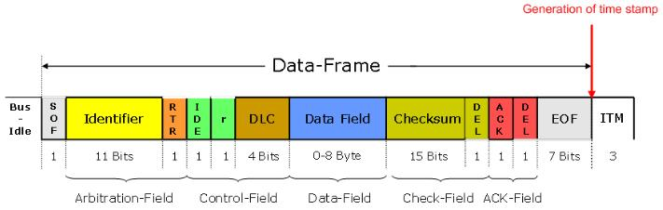
Fig 18 : CAN Data Frame

The data frame is the most common message type, and comprises the Arbitration Field, the Data Field, the CRC Field, and the Acknowledgment Field. The Arbitration Field contains an 11-bit identifier and the RTR bit, which is dominant for data frames. Next is the Data Field which contains zero to eight bytes o+f data, and the CRC Field which contains the 16-bit checksum used for error detection. Last is the Acknowledgment Field.

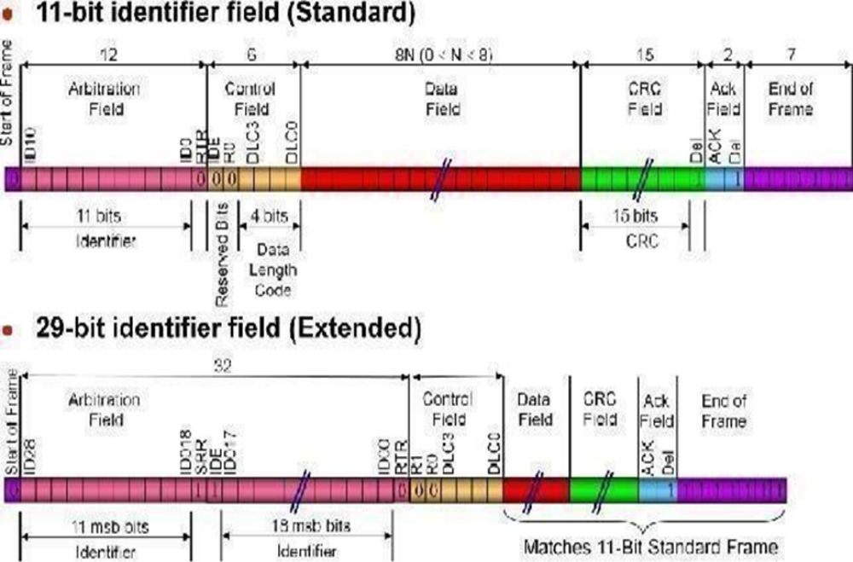
Fig 18 : CAN Data Frame

● Remote Frame:

The intended purpose of the remote frame is to solicit the transmission of data from another node. The remote frame is similar to the data frame, with two important differences. First, this type of message is explicitly marked as a remote frame by a recessive RTR bit in the arbitration field, and secondly, there is no data.

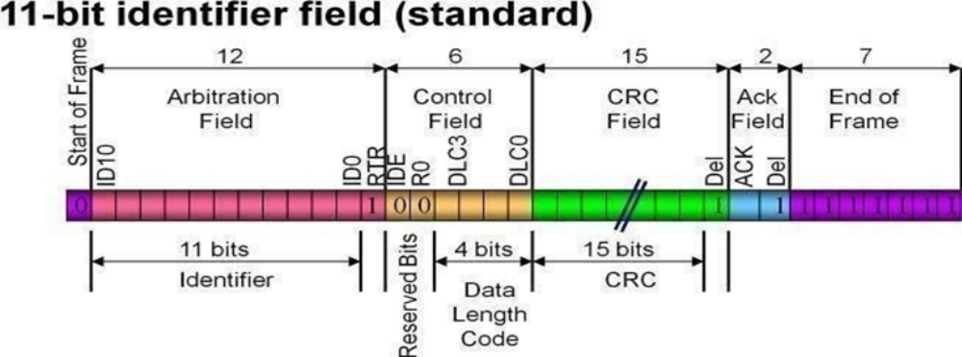
Fig 19 : CAN Remote Frame

● Error Frame:

The error frame is a special message that violates the formatting rules of a CAN message. It is transmitted when a node detects an error in a message and causes all other nodes in the network to send an error frame as well. The original transmitter then automatically retransmits the message. An elaborate system of error counters in the CAN controller ensures that a node cannot tie up a bus by repeatedly transmitting error frames.

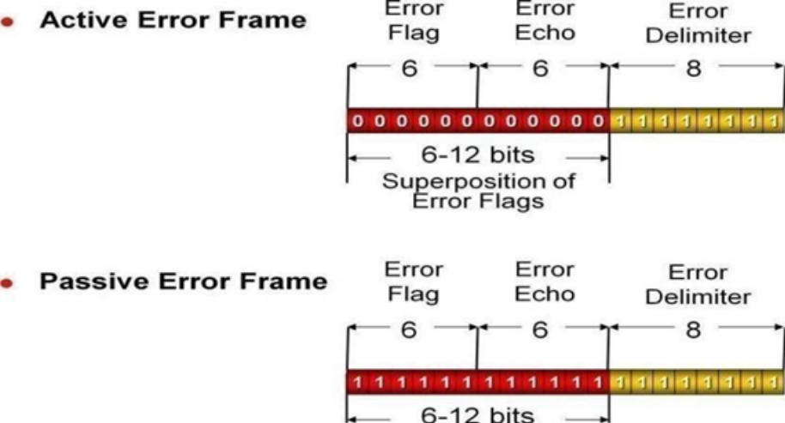
Fig 20 : CAN Error Frame

● Overload Frame:

The overload frame is mentioned for completeness. It is like the error frame with regardto the format, and it is transmitted by a node that becomes too busy. It is primarily used to provide for an extra delay between messages.

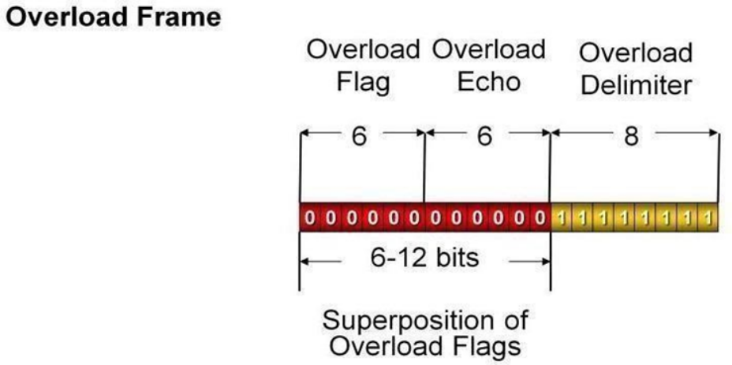
Fig 21 : CAN Overload Frame

● Bus Arbitration:

The CAN communication protocol is a carrier-sense, multiple-access protocol with collision detection and arbitration on message priority (CSMA/CD+AMP). CSMA means that each node on a bus must wait for a prescribed period of inactivity before attempting to send a message. CD+AMP means that collisions are resolved through a bit-wise arbitration, based on a pre- programmed priority of each message in the identifier field of a message. The higher priority identifier always wins bus access. That is, the last logic high in the identifier keeps on transmitting because it is the highest priority.

Whenever the bus is free, any unit may start to transmit a message. If two or more units start transmitting messages at the same time, the bus access conflict is resolved by bit-wise arbitration using the Identifier. The mechanism of arbitration guarantees that neither information nor time is lost. If a data frame and a remote frame with the same identifier are initiated at the same time, the data frame prevails over the remote frame. During arbitration every transmitter compares the level of the bit transmitted with the level that is monitored on and a ‟dominant‟ level is monitored, the unit has lost arbitration and must withdraw without sending one more bit. the bus. If these levels are equal the unit may continue to send.

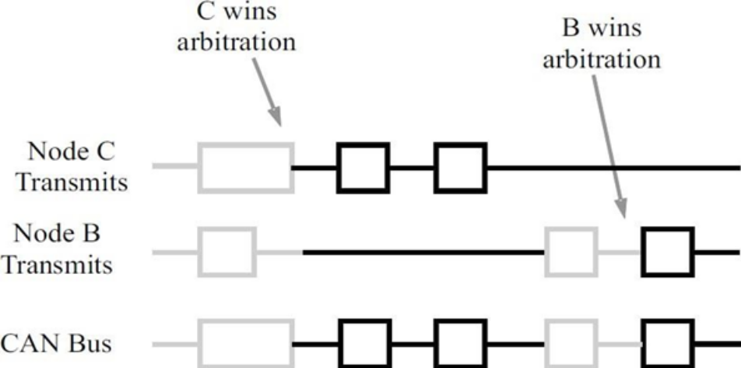
Fig 22 : Bus Arbitration

4.9.2 Universal Asynchronous Receiver Transmitter (UART):

UART means Universal Asynchronous Receiver Transmitter Protocol. UART is used for serial communication from the name itself we can understand the functions of UART, where U stands for Universal which means this protocol can be applied to any transmitter and receiver, and A is for Asynchronous which means one cannot use clock signal for communication of data and R and T refers to Receiver and Transmitter hence UART refers to a protocol in which serial data communication will happen without clock signal.

UART is established for serial communication. In this article, we will discuss how parallel communication is established with respect to serial communication using UART as well as how to configure UART and what is the data format in UART. Later on, we will discuss the Pros and Cons of the UART.

● UART Basics:

UART is a Universal Asynchronous Receiver Transmitter protocol that is used for serial communication. Two wires are established here in which only one wire is used for transmission whereas the second wire is used for reception. Data format and transmission speeds can be configured here. So, before starting with the communication define the data format and transmission speed. Data format and transmission speed for communication will be defined here and we do not have a clock over here that's why it is referred to as asynchronous communication with UART protocol. Here we will see how this protocol is designed physically.

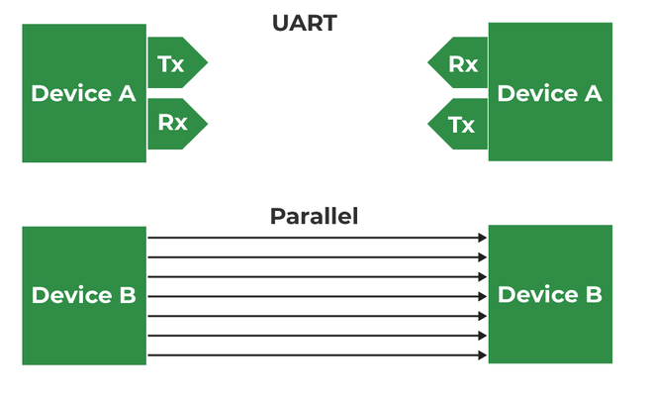
Fig 23 : UART

Here, DEVICE A that is having transmitter PIN and a receiver pin; DEVICE B is having a receiver and transmission pin. The Transmitter of DEVICE A is one that should be connected with the receiver pin of DEVICE B and the transmitter pin of DEVICE B should be connected with the receiver pin of DEVICE A we just need to connect two wires for communication.

If DEVICE A wants to send data, then it will be sending data on the transmitter’s pin and here receiver of this DEVICE B will receive it over and if DEVICE A wants to receive the data, then that is possible on the RX line that will be forwarded by TX of DEVICE B. On comparing this serial communication of UART with parallel then it can be observed that in parallel multiple buses are required. Based on the number of lines bus complexity of UART is better but parallel communication is good in terms of speed.

So, when speed is required at that time we should select parallel communication and for a low-speed application, UART must be used and the bus complexity will be less.

The configuration of UART is done before transmission, both of these devices are connected with protocol and should know the speed of data transmission. First, define the speed of both devices. Now, configure the speed of DEVICE A and B for data transmission which is referred to as Baud Rate so here Baud Rate will be the same for DEVICE A and B otherwise both of these devices cannot understand at what speed and at what rate data is coming. After that, configure the data length so here DEVICE A and DEVICE B both are configured at fixed data length if DEVICE A is transmitting data, then it is configured with fixed data. Like if DEVICE A is configured with the eight-bit size of data then DEVICE B should also be configured at the same size of data which is eight bits. After this, check data transmission or receiving time, forward start bits, and stop bits.

Now we will see the data format and when the communication is according to UART protocol. We are using NRZ encoding for data communication.

● UART Data Frame:

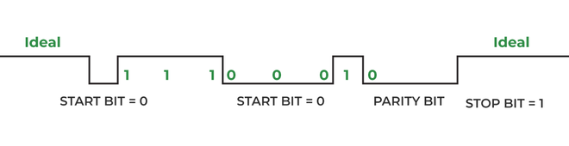
Fig 24 : UART Data Frame

Suppose DEVICE A is sending data to DEVICE B, and the transmitter of DEVICE A will send data to the receiver of Device B then it will be logic high. Now, send the start bit that will be logic 0 and once we have the start bit, DEVICE B will know that somebody is communicating. Now there is the same speed configuration with both devices. So, after the start bit, DEVICE A can forward data.

Consider 8 bits of data length, so we will be forwarding 8 bits and those 8 bits will be received by DEVICE B a parity bit can also be used which is optional, but this is quite effective. By using the parity bit, it can be identified whether the received data is correct or not. Suppose we are sending 1 1 1 0 0 0 1 0. Now, we have 4 ones; an even number of ones are there hence the parity is even and for that, logic 0 will be assigned. Suppose we are receiving data with some error, say zero is converted into one; Now incorrect data that is 1 1 1 1 0 0 1 0 for this incorrect data parity will be 0 as there are 5 ones, here is a mismatch in the parity bit and hence it is confirmed that the received data has some error.

RTOS:

4.10.1 Working of RTOS:

In the proposed Smart Car Dashboard System, FreeRTOS is used on the STM32F407VGT6 microcontroller to manage multiple real-time operations efficiently and deterministically. Since the system involves continuous sensor monitoring, real-time CAN communication, and system health supervision, a Real-Time Operating System is essential to ensure timely execution and reliability.

The FreeRTOS scheduler uses priority-based preemptive scheduling, allowing high-priority tasks to execute immediately when required. This ensures that time-critical operations, such as sensor data acquisition, are not delayed by lower-priority tasks.

Task-Based System Design:

Sensor Reading Task (High Priority):

This task is responsible for acquiring real-time data from all vehicle sensors, including motor RPM, vehicle speed, battery voltage, battery current, battery temperature, and safety inputs such as door and seatbelt status. The task executes periodically every 50 ms, ensuring fresh and up-to-date sensor data. High priority is assigned to this task to maintain real-time performance.

Sensor Reading Task (Medium Priority):

This task formats the processed sensor data into CAN frames and transmits them over the CAN bus. It runs every 100 ms and sends different CAN messages such as motor speed, vehicle speed, battery status, and safety status. Medium priority ensures that communication occurs reliably after sensor data has been updated, without blocking sensor acquisition.

System Monitor Task (Low Priority):

This task continuously monitors the health of the CAN bus and system status. It checks for CAN errors such as bus-off conditions and performs recovery actions if required. Since monitoring is not time-critical, this task is assigned the lowest priority and runs every 1000 ms.

Inter-Task Communication and Synchronization:

To safely share data between tasks, FreeRTOS synchronization mechanisms are used:

A mutex (VehicleDataMutex) protects the shared vehicle data structure from concurrent access, preventing data corruption.

A queue (CANMessageQueue) is used to buffer CAN messages before transmission, decoupling data preparation from actual CAN transmission.

This approach ensures smooth and non-blocking communication between tasks.

Deterministic and Reliable Operation:

FreeRTOS ensures deterministic task execution by allowing higher-priority tasks to preempt lower-priority tasks. Periodic delays using vTaskDelay() help maintain fixed execution intervals, while DMA-based ADC sampling reduces CPU load. The RTOS-based design improves system scalability, reliability, and fault isolation compared to a traditional super-loop architecture.

Chapter 5

RESULTS

The Smart Car Dashboard System was successfully designed, implemented, and tested using the STM32F407VGT6 microcontroller with FreeRTOS, CAN communication, an ESP32 gateway, a DWIN LCD display, and AWS cloud integration. The system operated reliably under real-time conditions and met all the intended functional objectives.

The STM32-based ECU was able to accurately acquire sensor data such as motor RPM, vehicle speed, battery voltage, battery current, battery temperature, and safety parameters including door and seatbelt status. The use of ADC with DMA and timer-based input capture ensured continuous and efficient data acquisition with minimal CPU overhead. The calculated battery State of Charge (SOC) correctly reflected changes in battery voltage and current.

FreeRTOS task scheduling enabled concurrent execution of sensor reading, CAN transmission, and system monitoring tasks with deterministic timing. High-priority sensor tasks executed at fixed intervals without interruption, while CAN transmission and monitoring tasks operated reliably at their respective periods. Mutex and queue mechanisms ensured safe inter-task communication and prevented data corruption.

The CAN communication between the STM32 and ESP32 was successfully established at a baud rate of 500 kbps. All CAN frames were transmitted with correct CAN IDs, data length, and payload structure. The system demonstrated robust CAN performance with error detection and recovery mechanisms, including automatic bus-off handling.

On the gateway side, the ESP32 correctly received and decoded all CAN messages using the MCP2515 CAN controller. Real-time vehicle parameters were displayed on the DWIN LCD dashboard with minimal latency. Speed, battery percentage, temperature, and warning indicators were updated smoothly, providing clear and user-friendly visualization.

Additionally, the ESP32 successfully transmitted vehicle data to the AWS IoT cloud using the MQTT protocol over Wi-Fi. Data was published in real time, enabling remote monitoring and logging of vehicle parameters. The system continued to function correctly even when cloud connectivity was temporarily unavailable, demonstrating proper separation of real-time and non-critical tasks.

Overall, the project achieved stable real-time performance, reliable communication, accurate data visualization, and successful cloud integration. The results validate the effectiveness of using an RTOS-based architecture with CAN communication for smart automotive dashboard and telematics applications.

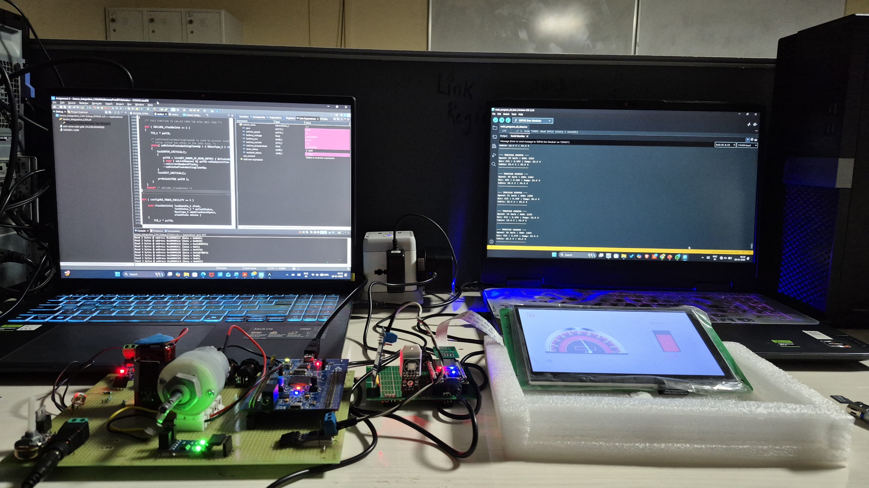

Fig 25 : Project Setup

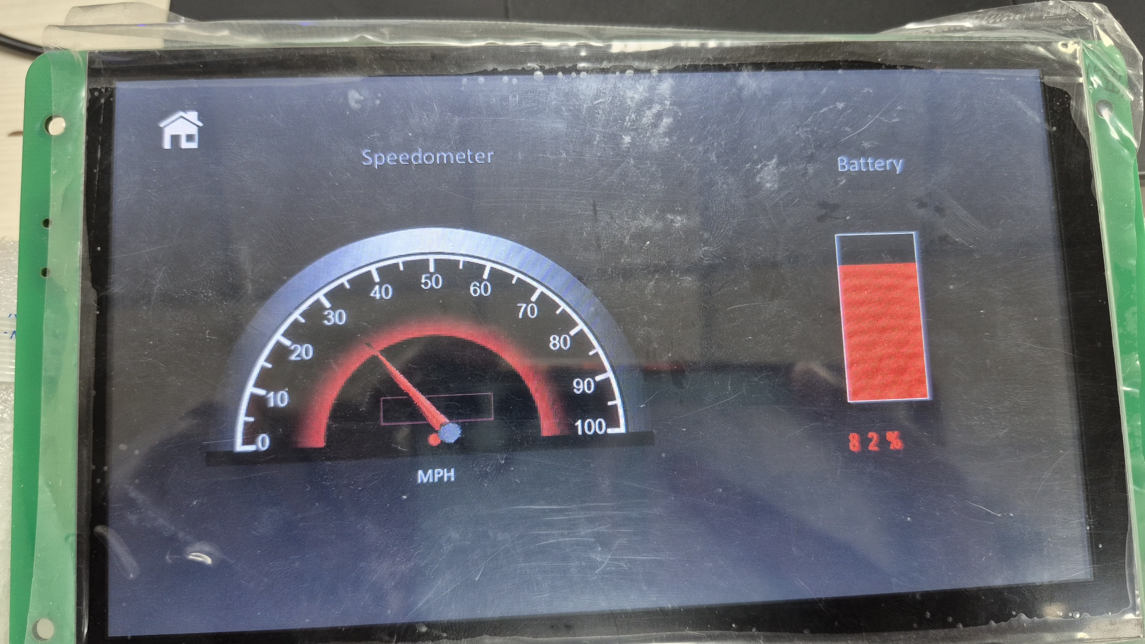

Fig 26 : DWIN Display showing Car Speed and Battery

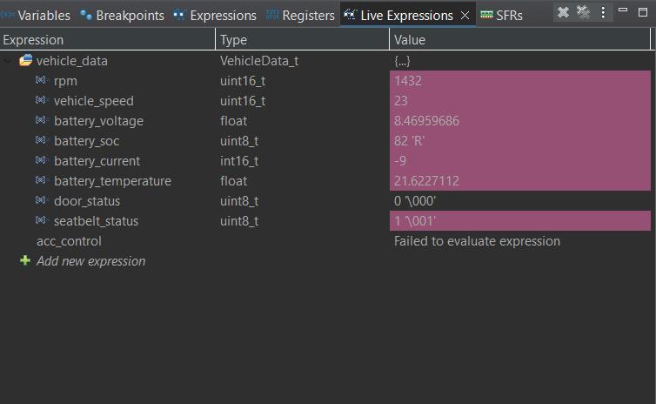

Fig 27 : Live Expression of Data Sending to ESP32 via CAN

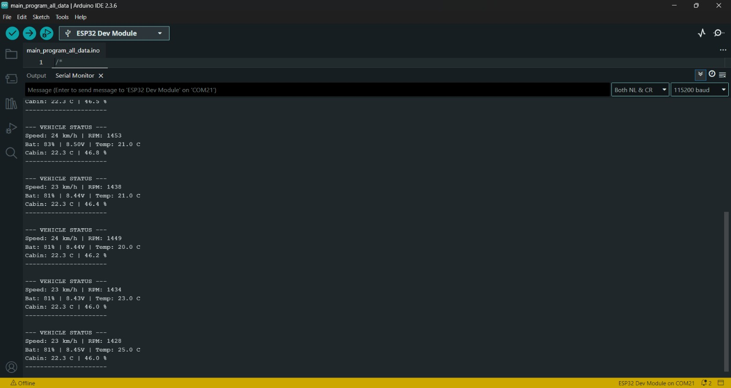

Fig 28 : Data Received From STM32 to ESP32 via CAN

Chapter 6

CONCLUSION

6.1 Conclusion

The Smart Car Dashboard System has been successfully designed and implemented to monitor and display real-time vehicle parameters using an embedded automotive architecture. The system effectively integrates the STM32F407VGT6 microcontroller running FreeRTOS, CAN communication, an ESP32 gateway, a DWIN LCD display, and AWS cloud connectivity. All major functional requirements of the project were achieved as intended.

The use of FreeRTOS enabled efficient multitasking and deterministic execution of sensor acquisition, CAN transmission, and system monitoring tasks. Real-time vehicle data such as speed, battery voltage, current, temperature, and safety status were accurately acquired and processed by the STM32 ECU. The CAN bus provided reliable and noise-immune communication between the ECU and the gateway controller.

The ESP32 successfully acted as a gateway by decoding CAN data and updating the DWIN LCD display in real time, providing clear and continuous visualization of vehicle information. In addition, the system demonstrated successful cloud integration by transmitting vehicle data to AWS IoT for remote monitoring and logging.

Overall, the project demonstrates a practical and scalable smart automotive dashboard solution that closely resembles real-world vehicle instrumentation and telematics systems. The implemented design validates the effectiveness of combining RTOS-based embedded control, CAN communication, and IoT technologies for modern automotive applications.

Future Scope:

The Smart Car Dashboard System developed in this project provides a strong foundation for further enhancements and advanced automotive applications. Several improvements and extensions can be incorporated in future work to increase system functionality and intelligence.

Enhanced IoT-Based Vehicle System:

The system can be extended to support advanced IoT features such as real-time alerts, geo-fencing, and cloud-based vehicle status notifications using AWS services.

Fault Diagnosis and Alerts:

Additional diagnostic features such as sensor fault detection, CAN error logging, and real-time warning alerts can be implemented to improve system safety and reliability.

Advanced Driver Assistance Features:

Basic ADAS functionalities such as collision warning indicators, adaptive cruise control status, and lane monitoring can be integrated using additional sensors and ECUs

Over-the-Air (OTA) Firmware Updates:

Firmware updates for the ESP32 and STM32 can be implemented using cloud-based OTA mechanisms, reducing maintenance effort and enabling remote system upgrades.

Mobile and Web Application Integration:

A mobile or web-based application can be developed to visualize vehicle data from the AWS cloud, enabling remote monitoring and user interaction.

Scalable Multi-ECU Architecture:

The CAN network can be expanded to include additional ECUs such as motor control, braking, and lighting systems, making the architecture closer to real-world automotive systems.

Cloud Data Analytics and Predictive Maintenance:

Vehicle data collected in the cloud can be analyzed to predict potential faults, optimize vehicle performance, and support preventive maintenance strategies.

Chapter 7

REFERENCES

[1] S. S. Patil, A. R. Shinde, and P. R. Patil, “Design and Implementation of Vehicle Dashboard System Using CAN Protocol,” International Journal of Engineering Research and Technology (IJERT), vol. 6, no. 4, pp. 120–124, 2017.
Reference: https://www.ijert.org/design-and-implementation-of-vehicle-dashboard-system-using-can-protocol

[2] Richard Barry, “Using the FreeRTOS Real Time Kernel – A Practical Guide,” FreeRTOS Documentation, 2020.
Reference: https://www.freertos.org/Documentation/RTOS_book.html

[3] S. Kumar, R. Singh, and A. Verma, “IoT Based Vehicle Monitoring and Tracking System,” International Journal of Advanced Research in Computer Engineering & Technology (IJARCET), vol. 7, no. 5, pp. 234–238, 2018.
Reference: https://ijarcet.org/wp-content/uploads/IJARCET-VOL-7-ISSUE-5-234-238.pdf

[4] A. R. Kulkarni and S. B. Patil, “Design of Digital Instrument Cluster for Automotive Applications,” International Journal of Engineering Science and Computing (IJESC), vol. 8, no. 3, pp. 18234–18238, 2018.
Reference: https://ijesc.org/upload/Design_of_Digital_Instrument_Cluster.pdf

[5] J. Lee, B. Bagheri, and H. A. Kao, “A Cyber-Physical Systems Architecture for Industry 4.0-based Manufacturing Systems,” Manufacturing Letters, vol. 3, pp. 18–23, 2015.
Reference: https://www.sciencedirect.com/science/article/pii/S221384631400025X

[6] M. A. Khan, S. R. Khan, and A. Ahmed, “Smart Vehicle Telemetry System Using CAN and IoT,” International Journal of Advanced Research in Electrical, Electronics and Instrumentation Engineering, vol. 6, no. 9, pp. 7321–7326, 2017.
Reference: https://ijareeie.com/upload/2017/september/42_Smart.pdf

[7] STM32F4 Series Reference Manual – STMicroelectronics.

Reference: https://www.st.com/en/microcontrollers-microprocessors/stm32f4-series.html

[8] ESP32 Technical Reference Manual – Espressif Systems

Reference:https://docs.espressif.com/projects/esp-idf/en/latest/esp32/hw-reference/index.html

[9] MCP2515 CAN Module Datasheet-Microchip Technology Inc.

Reference:https://ww1.microchip.com/downloads/en/DeviceDoc/MCP2515-Stand-Alone-CAN-Controller-with-SPI-20001801J.pdf

[10] SN65HVD230 CAN Transreceiver Datasheet-Microchip Technology Inc.

Reference: https://www.ti.com/lit/gpn/SN65HVD230.

[11] DWIN DMG80480C070 Display Datasheet-DWIN

Reference:https://ecdn6.globalso.com/upload/p/1355/source/2025-09/Datasheet-DMG80480C070_04W1.zip

